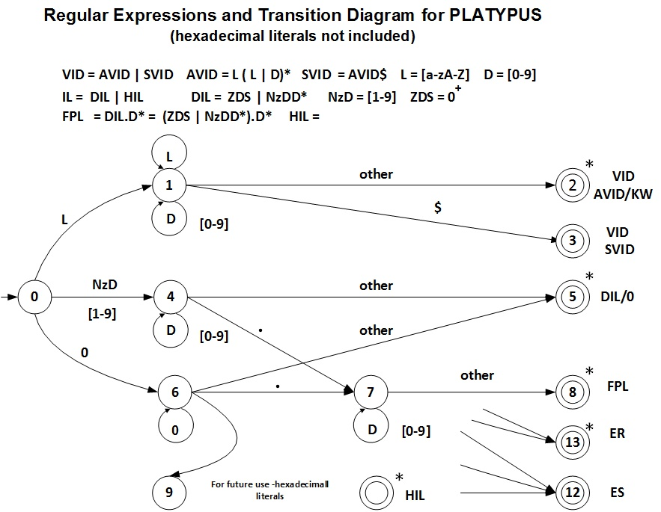

Transition Table

Current  State |  |  | INPUT SYMBOL |  |  |  |  |  |  | State Type  (Not Accepting or Accepting State)
Current  State | X | [a-zA-z] |  | [A-F] | 0 | [1-9] | . | $ | other | State Type  (Not Accepting or Accepting State)
0 | 1 | 1 |  | 1 | 6 | 4 | ES | ES | ES | NOAS`
1 | 1 | 1 |  | 1 | 1 | 1 | 2 | 3 | 2 | NOAS
2 | IS | IS |  | IS | IS | IS | IS | IS | IS | VID AVID/KW - ASWR
3 | IS | IS |  | IS | IS | IS | IS | IS | IS | VID SVID - ASNR
4 | 5 | ES |  | ES | 4 | 4 | 7 | 5 | 5 | NOAS
5 | IS | IS |  | IS | IS | IS | IS | IS | IS | DIL - ASWR
6 | 9 | ES |  | ES | 5 | ES | 7 | ES | 5 | NOAS
7 | ES | 8 |  | ES | 7 | 7 | 8 | 8 | 8 | NOAS
8 | IS | IS |  | IS | IS | IS | IS | IS | IS | FPL - ASWR
9 | ES | ES |  | 10 | 10 | 10 | ES | ES | 12 | NOAS
10 | ES | ES |  | 10 | 10 | 10 | ES | ES | 11 | NOAS
11 | IS | IS |  | IS | IS | IS | IS | IS | IS | HIL – ASWR
12 | IS | IS |  | IS | IS | IS | IS | IS | IS | ES - ASNR
13 | IS | IS |  | IS | IS | IS | IS | IS | IS | ER - ASWR

IS – Illegal State ES – Error State ES/AS – Error State or Accepting State
NOAS – Not Accepting State ER – Error State with Retract
ASWR - Accepting State With Retract ASNR - Accepting State No Retract

